Andy Martino, Southampton FC development manager and FA affiliate tutor, returns with a session plan delivered in a ‘whole-part-whole’ style, aimed at players aged 5-11.
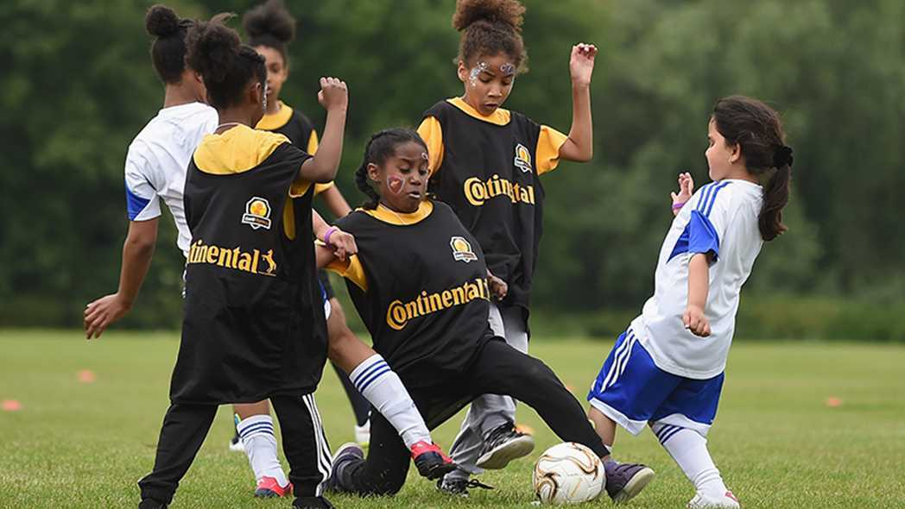
The session is organised in a ‘whole-part-whole’ style. I believe this works well within the younger aged groups in particular as it helps the children see the practice in a game-related style.

How does the session relate to The FA’s 4-corner-model?
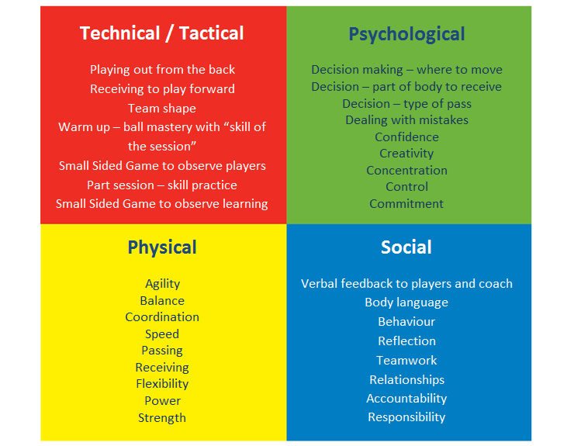

Key Factors to consider
- Awareness of players and areas
- Body position
- Awareness
- Movement
- Receive on back or front foot
- Type of pass (weight, when and where) forward
- End product
- Communication

1) Warm-up - Skill and ball mastery - 25 mins
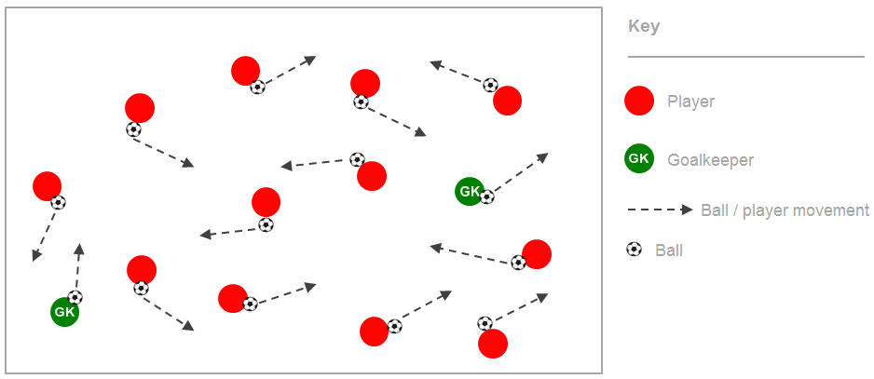

Coaching Points
- Players have a ball each and work on various skills to warm the body
- During the practice, introduce a “skill of the session”.
- Challenge players in to a competitive game with a 60 second time limit to see how many touches on the ball players can get
- Organised in to 3 sections of 20 seconds with 3 different skills (1 skill has to be the “skill of the session”)

2) Small Sided Game Part 1 - 20 mins
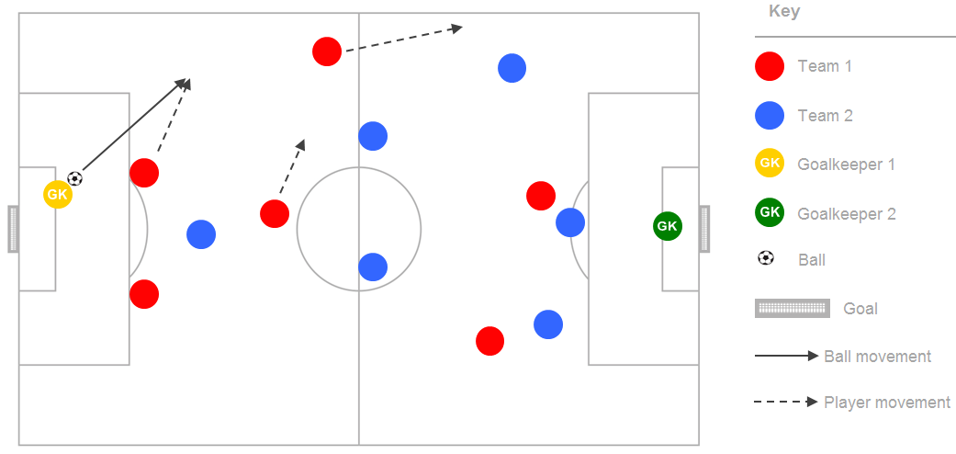

Coaching Points
- 7 v 7 game
- Observe how players are dealing with receiving to play forward and especially playing out from the back
- Encourage players to use the “skill of the session” from previous activity
- Allow players to have their own formation

3) Playing out from the back skill session - 20 mins
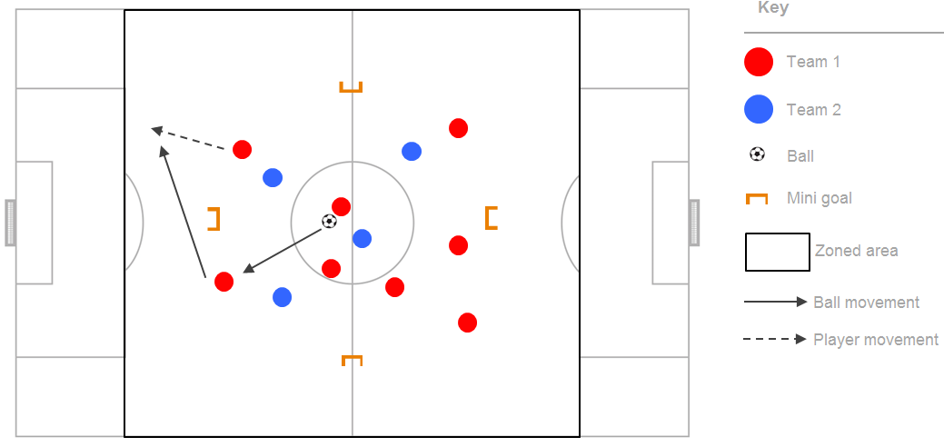

Coaching Points
- Start with an overload of 9v5
- Players keep possession and score with a one touch finish into the target goals
- Progress the practice by playing a 8v6 followed by a 7v7
- Condition passes if needed to help the players with the learning objective of working on receiving to play forward

4) Small Sided Game Part 2 - 20 mins
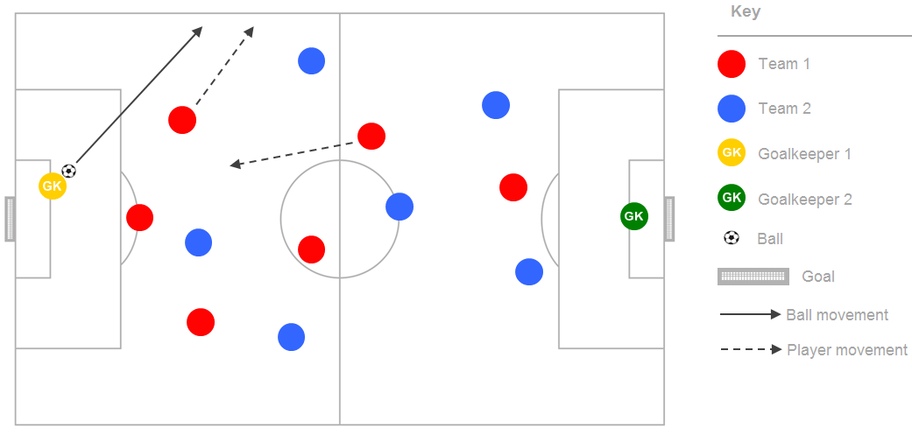

Coaching Points
- Players now go back into a 7v7 game
- Encouraging and spotting positive play when the objectives are met
- Award bonus points for using “skill of the session”
- Place teams into formations to begin
- Reinforce the key factors

